Case Study – Older Adult

Client consultation record (older adult)
Gym-based programme planning and preparation (D/616/7950)
Assessment element 6

Client’s name | Age | Gender
Mrs Vivien Robinson | 65 | Female
Description of lifestyle, to include: family, occupation, hobbies etc
Vivien is a grandmother of 3 who is recently retired. Now she is retired she has a little spare time and would like to make fitness and activity a hobby. Other hobbies include bowling with her friends and reading, alongside looking after her grandchildren.
Vivien is very keen to stay active and healthy so she can continue to look after her grandchildren. She wants to manage her weight and do a little resistance training in particular as she is aware it can assist with posture, and she has a family history of diabetes and arthritis, although to date she hasn’t been affected.
Description of present exercise and physical activity  levels (apply FITT where appropriate) | Description of past exercise and physical activity levels  (apply FITT where appropriate)
Frequency: bowling x1 per week, walking x3 per week  Intensity: light to moderate  Time: bowling 2 hours, walking 30-45 minutes  Type: mostly light cardiovascular | Very active as a ‘young person’ but less so for the past  10 years.
Client’s activity likes and dislikes
Likes: | Dislikes:
Walking and her bowling hobby  Thinks she would enjoy group classes as well as the gym although she’s never tried them. She’s willing to  give most activity a try | Swimming  Jogging

Client PAR-Q/PAR-Q + completed and informed  consent explained: YES/NO | Did the client answer YES to any PAR-Q/PAR-Q +  questions? NO
Analysis of PAR-Q/PAR-Q + responses and actions if applicable.
Although Vivien didn’t answer yes to anything on the form, she is concerned about her family history of arthritis
and diabetes.
Results from health assessments (conduct the physical measurements/assessments as appropriate to the
client and goals)
Test | Results
Resting heart rate | 73
Blood pressure | 125/85
Height and weight | 1.57m  71kg
BMI | 28.8
Waist circumference | 87 cm
Waist to hip ratio
LEARNER TO COMPLETE
1) Results analysis – list any considerations for the programme based on the above consultation form.

2) State whether you think the client should be referred to an appropriate professional prior to taking
part in physical activity, giving your reasons for referral (you may also utilise risk analysis tools such as
ACSM/Irwin and Morgan).
1:

2:

Appendix 3b
Case study (Younger person)

Gym programme card
Gym-based programme planning and preparation (D/616/7950)
This blank card should be photocopied to provide further programmes for the range of clients in
element 6, which includes a young person and an older adult.
Note: All components may not be suitable for some clients.

Learner’s name:
Client’s name: Mrs Vivien Robinson
Training goals:
Date:

Warm up – component length: ____________________

Overview of content, including  mobility, pulse raising (CV  machine as needed) and  component length | Equipment and  duration | Level/speed | RPE/HR | Adaptations or  alternatives
Preparatory stretches – list static and/or dynamic stretches here
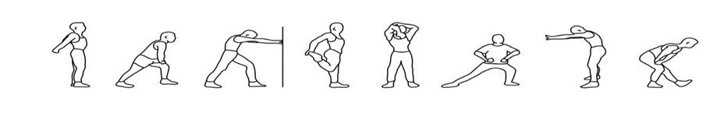
List muscle groups to stretch dynamically here:

Resistance training component length: ____________________

Exercise/machine | Resistance | Reps | Sets | Rest | Adaptations or alternatives to  suit client
Body weight exercise (including any functional/motor  skills exercises appropriate for the client) |  |  | Sets/reps/rest or duration of activity

Cardiovascular training (1 or more machine) – component length: ____________________

Equipment and approach | Programme  timings | Level/speed | RPE/HR | Adaptations or  alternatives to suit client

Cool down/flexibility – component length: ____________________

Cool down (if a re-warm or pulse lowering phase is required please detail in the space below)
CV machine (as  needed) | Time and intensity range
Post-workout stretches – indicate which stretches are maintenance (M) or developmental (D)
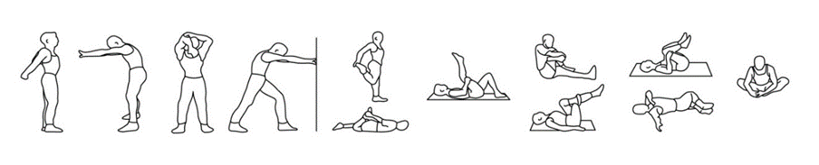
List additional stretches here:

Suggest other activities the client may be interested in within the fitness facility to complement their
programme.
Programme review dates.

Programming for client and from case studies assessment record and feedback (Assessor)
Gym-based programme planning and preparation (D/616/7950)
Learner’s name: |  |  |  | Date:
Assessor’s name: |  |  | IQA’s name:
The learner needs to achieve Pr1 through Pr6 to gain an overall pass in this section. Questioning is not permitted to confirm competence of practical skill. If the learner fails to meet the requirements of this section in full, they will need to be reassessed on this component of the session.
Programme
The learner demonstrated that they:
Pr1: Interpreted client information from consultation and screening for 2 clients (older adult, younger person) to select appropriate gym-based exercises to develop components of fitness, to include:
- cardiovascular fitness
- muscular fitness
- flexibility
- motor skills and functional ability
Pr2: Suggested some appropriate activities to complement the client’s programme according to their interests and goals.
Pr3: Planned realistic timings for each component within the programme.
Pr4: Planned safe and effective warm ups and cool downs including appropriate mobility/stretching.
Pr5: Identified methods of training suitable for the individual client for each component as appropriate
Pr6: Recorded programme plans in an appropriate format.
Assessor name: |  | Assessor signature:
Older Adult Outcome | PASS/REFER | Date
Assessment Element 6 Case Study Programme Cards Assessor feedback: Older Adult:

