My Group Fit free download:

Receive email from my group fit:

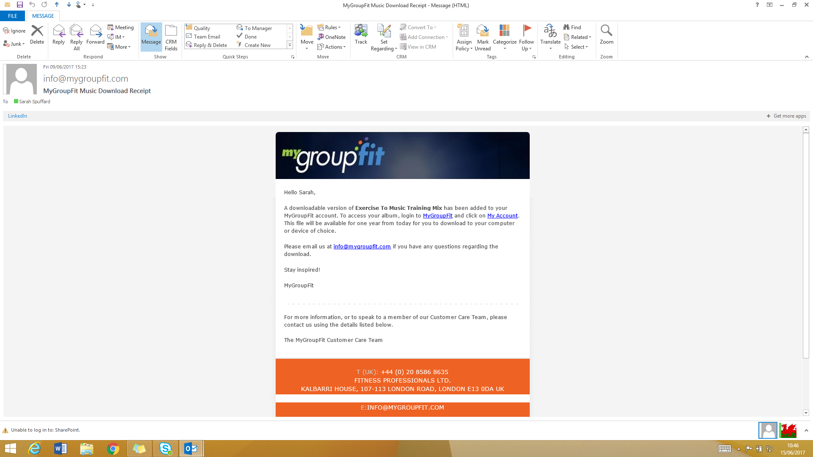

This will be followed by another email with your log in details and password. Click on mygroupfit link and enter the log in details sent to you.
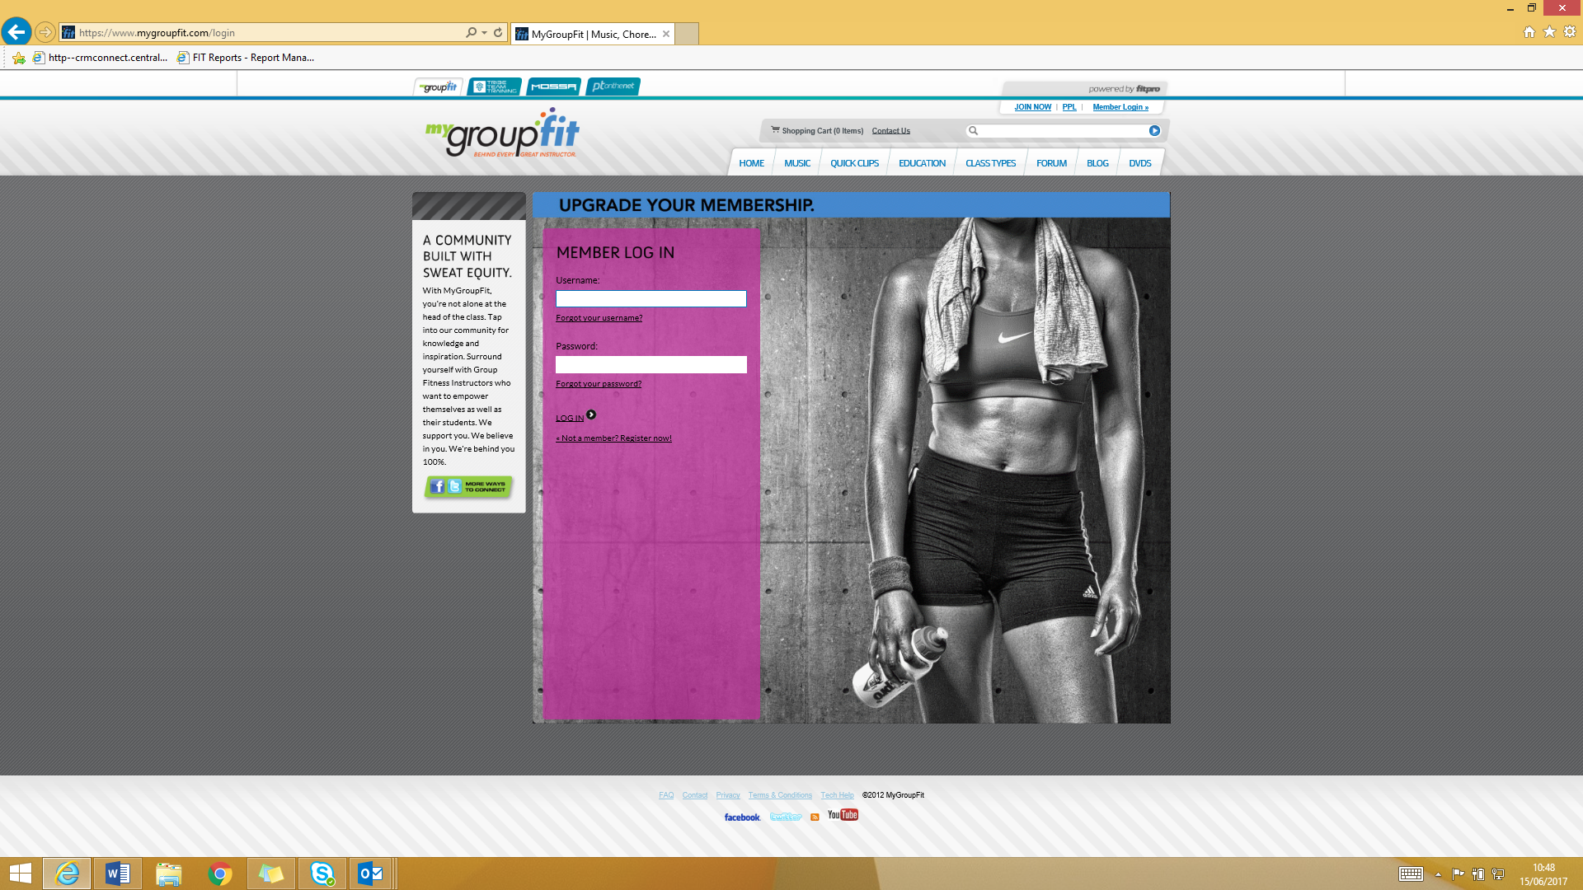

You are then taken to the homepage:
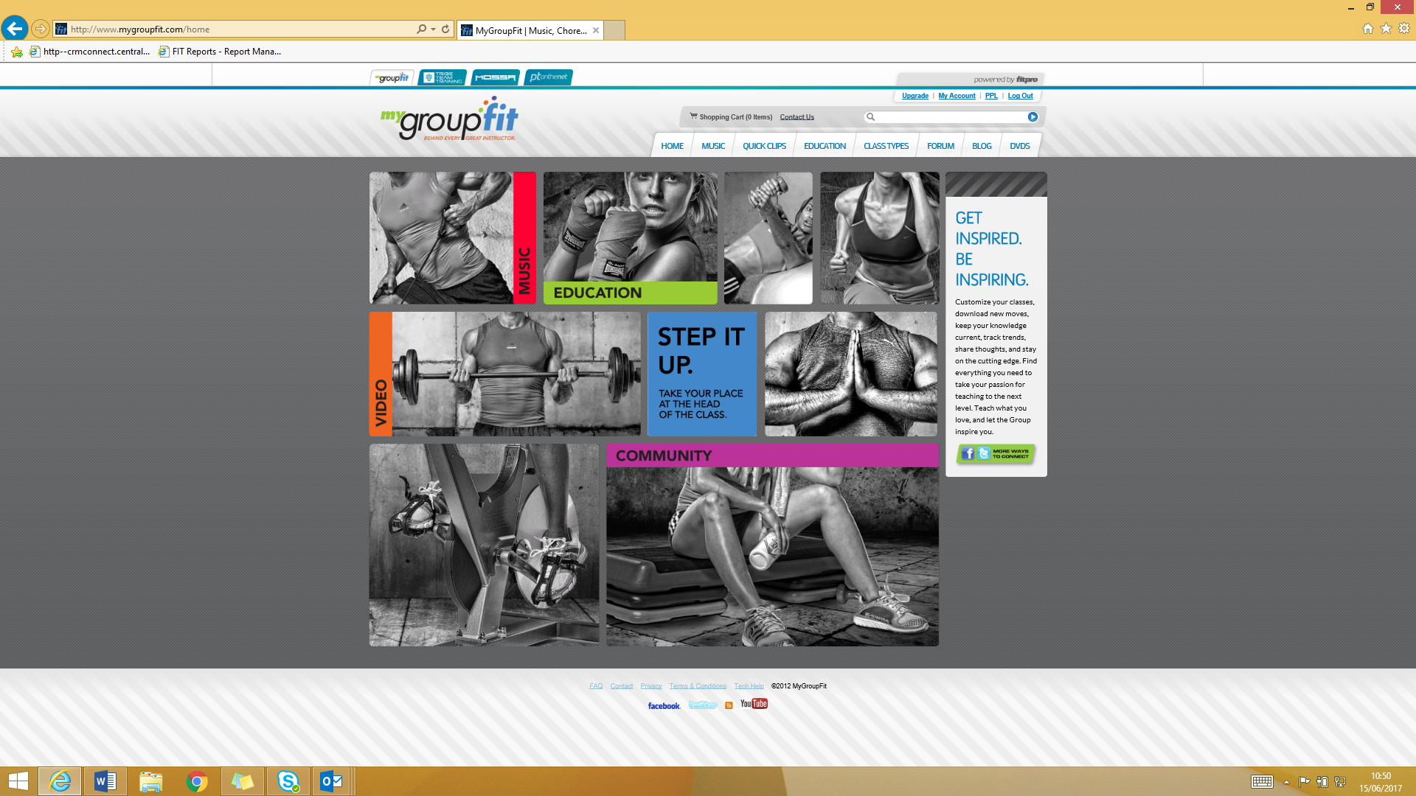
Click on my account:
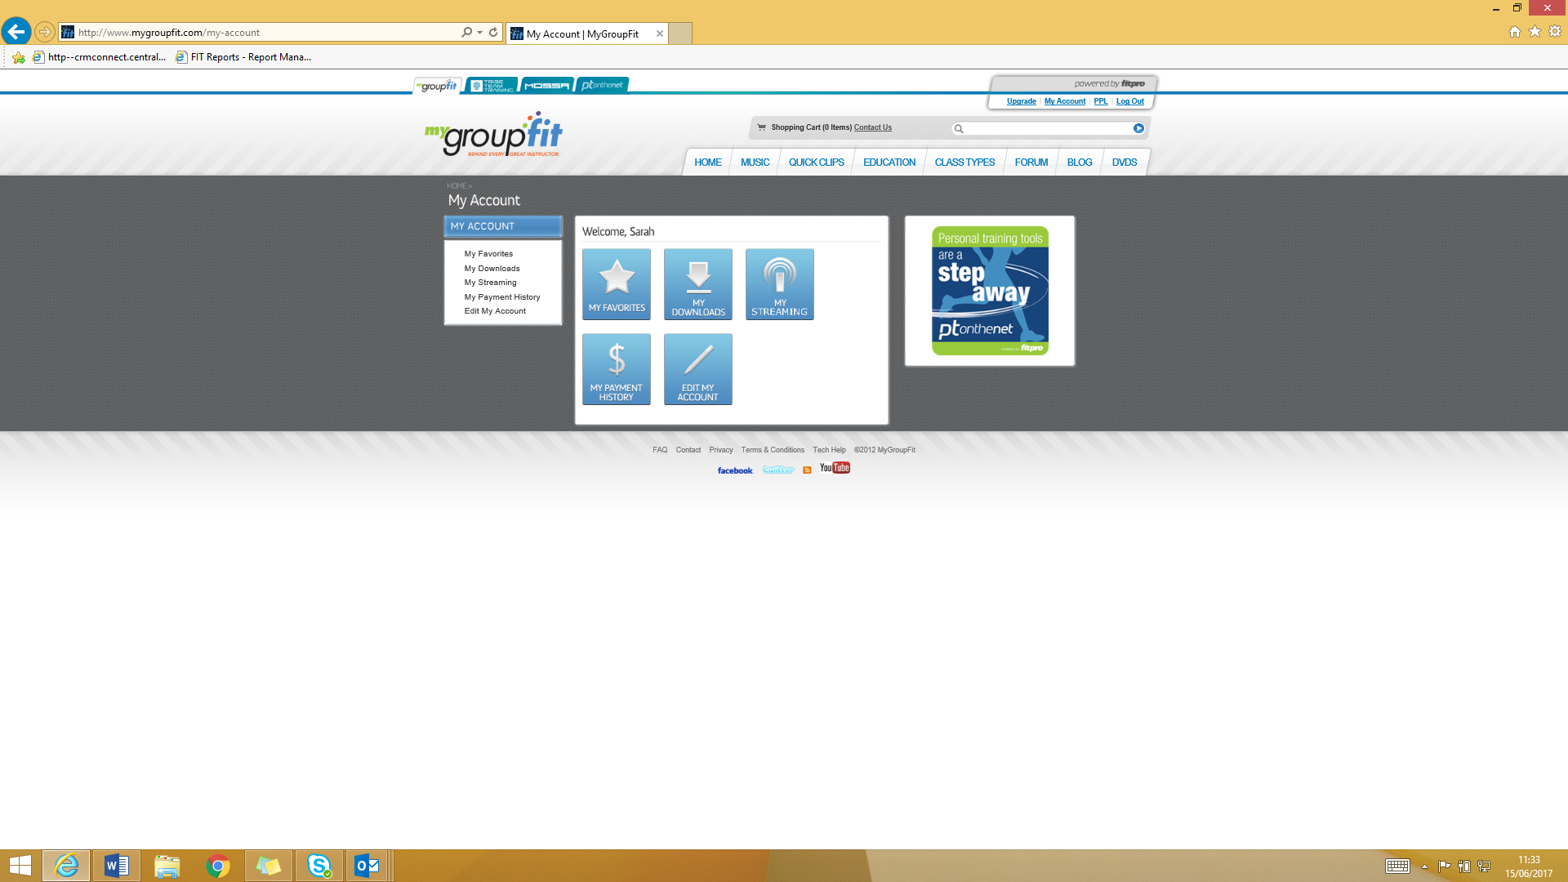

Click downloads and the CD will show, select download. It will take a couple of minutes for it to download. The file will then appear in your documents and the list of songs show as below:
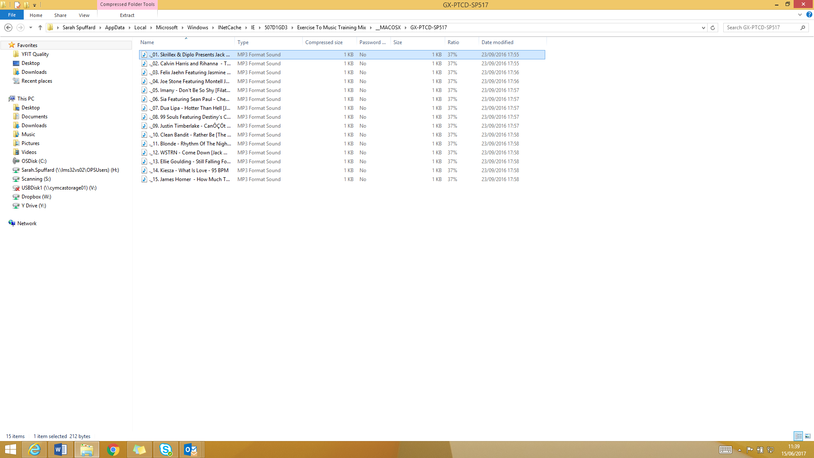

If you are logged into your account and you choose to buy a CD it will discount you down automatically.
If you have any questions you can contact My Group Fit directly.

