Gym programme overview – end of course summative observation
Learner’s name:
Client’s name:

Session and venue details
Venue: |  |  | Location of first aid kit:
Duty first aider: |  |  | Location of telephone:
Discipline: Gym-based exercise |  |  | Duration of session:
Client information
Informed consent form completed: YES / NO |  |  | PAR-Q completed: YES / NO
Height: | Weight: |  |  | BMI:
Session objectives (as agreed by client):

Any specific consideration relating to the client (e.g. injuries, exercise likes/dislikes, clothing)

Environment checks – list the health and safety (to include cleaning/hygiene) checks made to the following. List any actions.
Gym/studio: |  |  | Fire exits:
Temperature/ventilation: |  |  | Obstacles/hazards:
Organisation of equipment/resources
Equipment requirements: |  | List of health and safety checks made to equipment:
I (the client) agree with the session objectives outlined above.
Client’s signature: |  | Date:

Gym Programme Card Healthy Adult
Gym-based programme planning and preparation (D/616/7950)
Learner’s name:
Client’s name:
Training goals:
Date:

Warm up – component length

Overview of content, including mobility, pulse raising (CV machine as needed) and component length | Equipment and duration | Level/ speed | RPE/HR | Adaptations or alternatives
Preparatory stretches – circle static stretches and list the muscle groups to be stretched dynamically
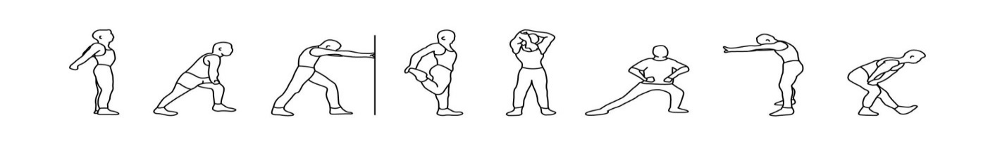
List muscle groups to stretch dynamically here:

Resistance training (4 machines, 4 free weight exercises) – component length
Exercise/machine | Resistance | Reps | Sets | Rest |  | Adaptations or alternatives to suit client
Body weight exercise (including any functional/motor skills exercises appropriate for the client) |  |  | Sets/reps/rest or duration of activity
Cardiovascular training (1 or more machine) – component length
Equipment and approach | Programme timings | Level/ speed | RPE/HR | Adaptations or alternatives to suit client
Cool down/flexibility – component length

Cool down (if a re-warm or pulse lowering phase is required please detail in the space below)
CV machine (as needed) | Time and intensity range
Post-workout stretches (circle as applicable) – indicate which stretches are maintenance (M) and which are developmental (D):
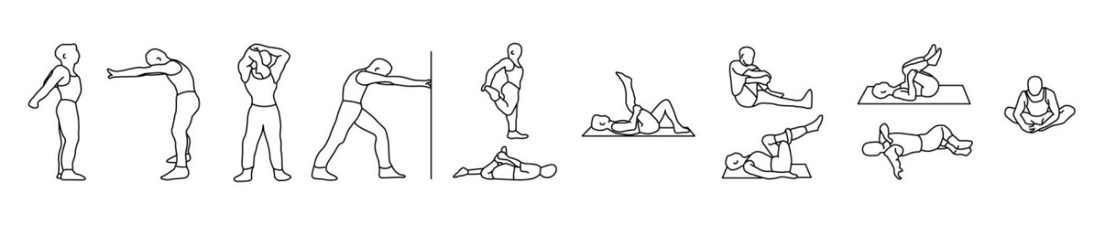
List developmental stretches here:

Suggest other activities the client may be interested in within the fitness facility to complement their programme.

Programming for client assessment record and feedback (Assessor)
The learner must: | The assessor must:
Write 1 exercise programme:  - One (1) programme for a healthy client aged 16 or over. Based on information obtained during the client consultation  Paperwork required:  - Client consultation paperwork  - Written programme card for the above client | This task does not need to be observed.  Ensure that during the completion of this task the learner meets all the learning outcomes on the supplied record. Once a decision has been made the assessor must check the descriptor below for a ‘pass’ for each learning outcome and in the space provided give clear feedback on how they made their assessment decision.
Gym-based programme planning and preparation (D/616/7950)
Learner’s name: |  |  |  | Date:
Assessor’s name: |  |  | IQA’s name:
The learner needs to achieve Pr1 through Pr6 to gain an overall pass in this section. Questioning is not permitted to confirm competence of practical skill. If the learner fails to meet the requirements of this section in full, they will need to be reassessed on this component of the session.
The second ‘Date’ and ‘Reassessment’ columns are for reassessment should the learner not achieve a pass against all criteria.
Programme
The learner demonstrated that they:
Pr1: Interpreted client information from consultation and screening for 1 client (healthy adult), to select appropriate gym-based exercises to develop components of fitness, to include:
- cardiovascular fitness
- muscular fitness
- flexibility
- motor skills and functional ability
Pr2: Suggested some appropriate activities to complement the client’s programme according to their interests and goals.
Pr3: Planned realistic timings for each component within the programme.
Pr4: Planned safe and effective warm ups and cool downs including appropriate mobility/stretching.
Pr5: Identified methods of training suitable for the individual client for each component:
- Planned for the use of a minimum of 2 different types of cardiovascular equipment
- Planned 4 resistance machine lifts
- Planned 4 free weight exercises
- Planned 2 body weight exercises (which can include motor skills or functional)
Pr6: Recorded programme plans in an appropriate format.
Planning Task 2 Date | Outcome | Date | Reassessment

Assessor feedback as to how the learner met the outcomes above. Reference using Pr1 to Pr6.

