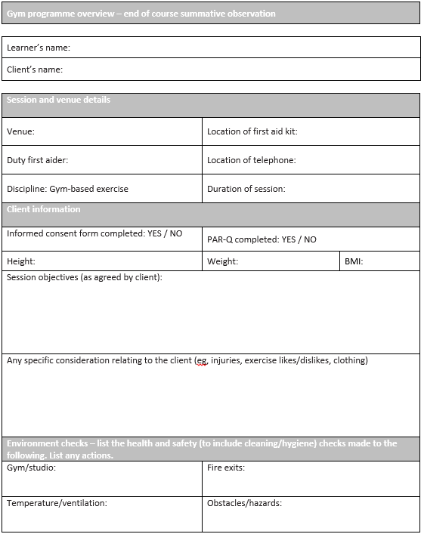
Ensure both names are entered here
Session and venue details

Ensure all boxes are filled in accurately

Client information
Informed consent and PAR-Q: Once you’ve completed both (or if the programme card is for a case study) circle yes

Height and weight: Provide both values in metrics (kilograms & meters)

BMI: calculate the BMI score for your client using the height and weight

Session objectives: Here give a brief overview of the objectives which you would discuss and agree with the client prior to the session. E.g. to improve CV endurance and core strength. Ensure your session matches the objectives.

Any specific consideration relating to the client: here state anything you will consider when planning the session based on information you have gathered from the client. E.g. injuries, clients likes/dislikes, equipment availability or anything else you are aware of that may be a consideration for the session
Environment checks
Ensure each section is filled in appropriate to the environment the session is going to take place

Organisation of equipment/resources
In the left column list the equipment required for the session
In the right column list the health and safety checks required (if any) for each piece of equipment listed on the left
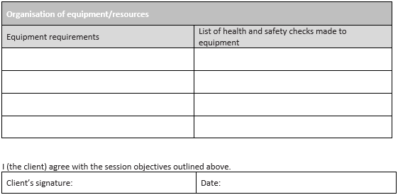

Ensure the client has signed and dated here

Overview of content
Give a brief overview of the types of exercises/movements contained in the warm up and the approximate time of the warm up in total
Equipment and duration
List the equipment used for each section of the warm up and time planned for each
Level/speed
Here provide the levels/speeds/gradients of the CV equipment (your warm up should show a gradual progression in intensity, not a flat intensity for the duration)
RPE/HR
As with the level/speeds you should show a gradual increase in intensity
Adaptations or alternatives
Provide an alternative exercise that will have the same affect or an alternative piece of equipment the client can use which will achieve the same affect

Prep stretches
Here list any static or dynamic stretches you will plan and include time held or number of reps to be performed for each
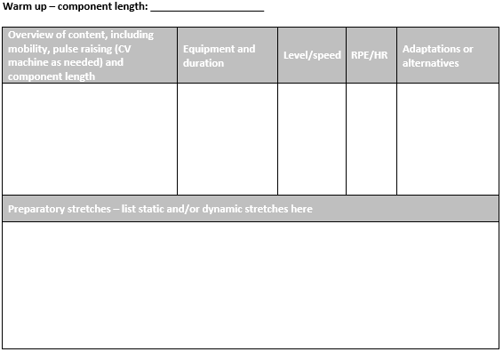

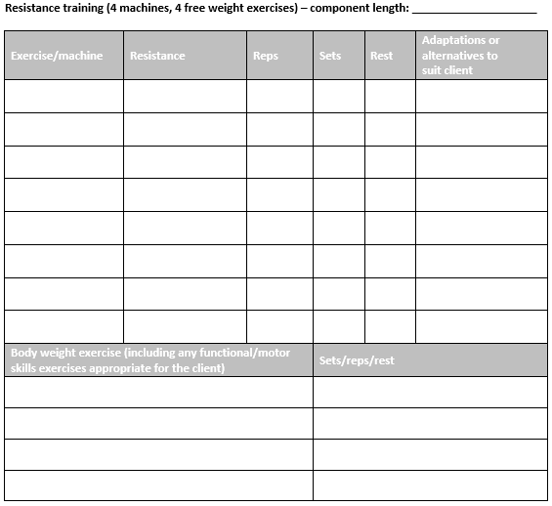

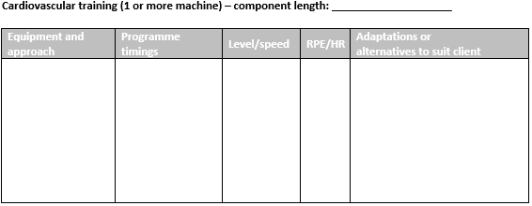

Resistance training
List 4 free weight exercises (dumbbell or barbell) and 4 resistance machines from appendix 1 in your LAR. The resistance column should show the estimated weight your client will use (this can be adapted if you are delivering this session).
Reps, rest and time
Ensure these columns are in line with the muscular strength and endurance continuum as per your clients session objectives e.g. if the objective of the session is hypertrophy don’t plan a rep range that falls in to muscular endurance or strength rep ranges
Adaptations
For each exercise provide an alternate exercise that works the same muscle group or an adaptation for the exercise (easier or harder way to perform the exercise)

Body weight
Provide four body weight exercises here. The focus of these exercises could be the same as the rest of the resistance section (muscular endurance or strength etc.) or the focus could be on motor skill development.

Cardiovascular training
This is the main CV section of the session.
Equipment and approach
List the equipment to be used as well as the method/approach (continuous, interval or fartlek).
Programme timings
Detail the time spent at each level e.g. if intervals show the work rest ratio including times: 1 minute work/1 minute rest x 10. If continuous show an aerobic curve.
Level/speed
Ensure the levels and speeds match the programme timings
RPE/HR
You need to detail here the different target RPE or HR for the session. Ensure you detail all sections of the session e.g. if it’s an interval session provide a target RPE/HR for the work and the rest intervals
Adaptations or alternatives
For each piece of equipment list either an easier or harder adaptation or an alternative piece of equipment where the same training affect can be achieved

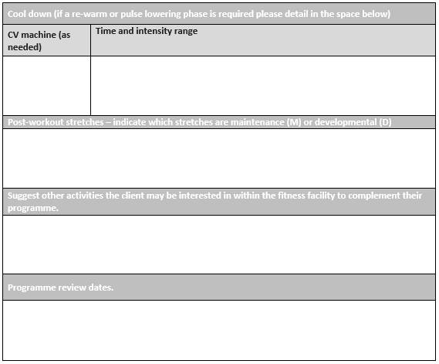

Cool down

In the top row provide the CV machine to be used.
*you need to use at least two different CV machines across the whole programme card (warm-up, main CV and cool down)

Post workout stretches
Provide a post-workout stretch for all of the main muscle groups used within the main session. State whether each stretch is a maintenance or developmental stretch, you must plan at least one developmental stretch.

Suggest other activities…
If there are any other activities that may complement or supplement the session detail them here

Programme review date
Here provide a date in the future where the session and the client progress will be reviewed by the trainer and the client

