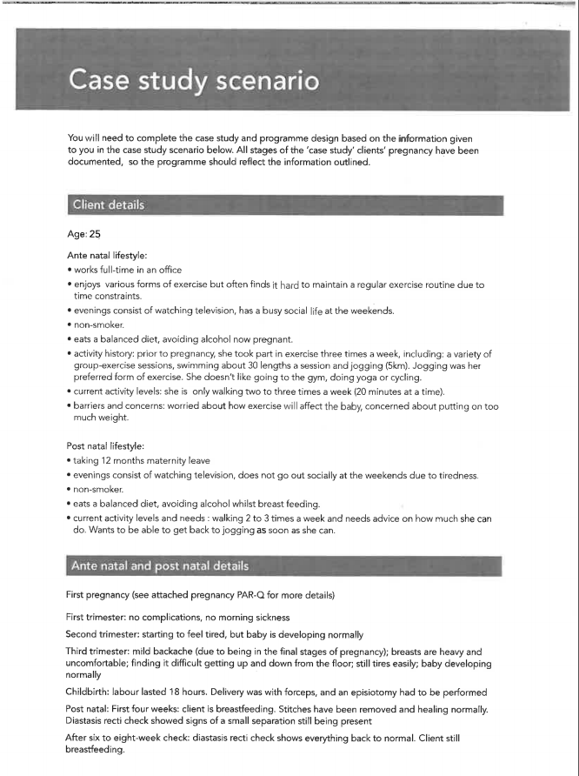

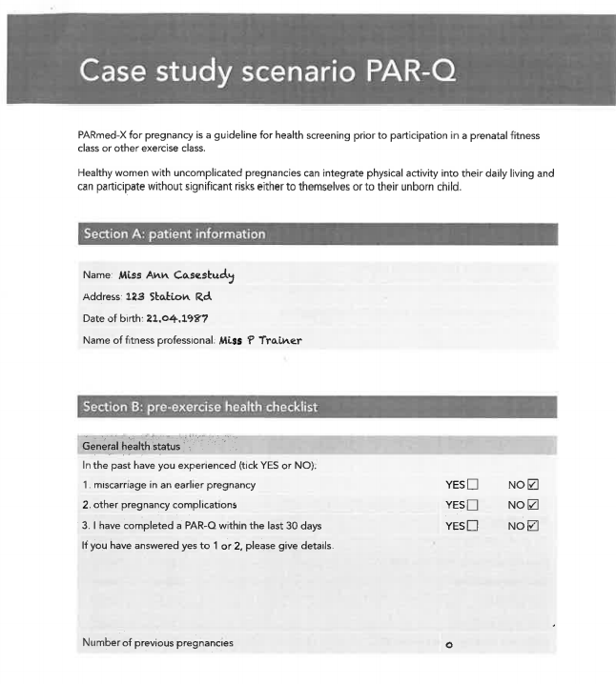

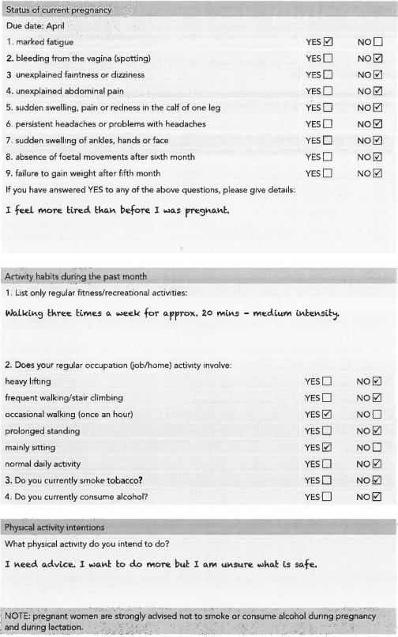
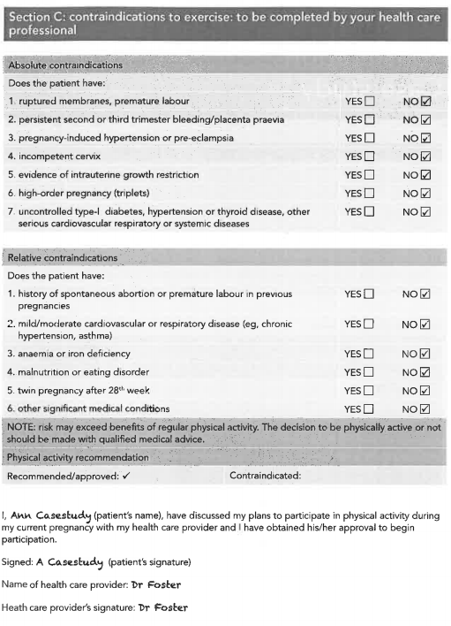
Lifestyle, attitudes and barriers consultation
Case Study

Give a brief overview of the client’s current lifestyle.

Client’s physical activity levels

 | Prior to pregnancy | Currently (before recommended programme) | Post-natal recommendations
Frequency
Intensity
Time
Type

Client’s activity preferences

Likes | Dislikes

Summarise the client’s attitude and motivation to exercise

Summarise the client’s barriers to exercise

Perceived barriers | Actual barriers

Medical History and pregnancy history
See pregnancy PAR-Q
Based on the analysis of the client’s pregnancy PAR-Q and the details given in the scenario, list any special recommendations or adaptations that may need to be considered when developing the client’s programme.

PAR-Q analysis | Considerations for programme design

Goal and needs

Based on the information given in the lifestyle and medical sections above, list the client’s overall needs and set realistic goals for the client.

Client’s needs

Client’s SMART goals
During pregnancy:
Post pregnancy:

Learner’s signature: |  | Date:
Assessor’s signature: |  | Date:
IQA’s signature: |  | Date:

Ante natal and post-natal programme: Warm-up
Component duration:
Resources Requires:

This session is based on the client in the case study and covers the first trimester of pregnancy and highlights the changes that would be made during the second and third trimesters and the post-natal period after the 6 to 8 week check.
First trimester exercise, intensity and duration | Pregnancy-specific teaching points | Adaptations for second trimester | Adaptations for third trimester | Post-natal adaptations

First trimester exercise, intensity and duration | Pregnancy-specific teaching points | Adaptations for second trimester | Adaptations for third trimester | Post-natal adaptations

Ante natal and post-natal programme: CV component
Component duration:
Resources Requires:

First trimester exercise, intensity and duration | Pregnancy-specific teaching points | Adaptations for second trimester | Adaptations for third trimester | Post-natal adaptations

First trimester exercise, intensity and duration | Pregnancy-specific teaching points | Adaptations for second trimester | Adaptations for third trimester | Post-natal adaptations

Ante natal and post-natal programme: muscular fitness component
Component duration:
Resources Requires:

First trimester exercise, intensity and duration | Pregnancy-specific teaching points | Adaptations for second trimester | Adaptations for third trimester | Post natal adaptations

First trimester exercise, intensity and duration | Pregnancy-specific teaching points | Adaptations for second trimester | Adaptations for third trimester | Post natal adaptations

Ante natal and post-natal programme: pelvic floor, stretch and relaxation component
Component duration:
Resources Requires:

First trimester exercise, intensity and duration | Pregnancy-specific teaching points | Adaptations for second trimester | Adaptations for third trimester | Post natal adaptations

First trimester exercise, intensity and duration | Pregnancy-specific teaching points | Adaptations for second trimester | Adaptations for third trimester | Post natal adaptations

Ante natal and post-natal programme: activities of daily living (ADLs)
First trimester exercise, intensity and duration | Adaptations for second trimester | Adaptations for third trimester | Post-natal adaptations
Post-natal only: give details of appropriate activities for the following stages:
Immediately after birth (first 6 weeks)
Post-natal progression (activity advice for eight weeks onwards)

CYQ Level 3 Award in Adapting Exercise for Ante Natal and Post Natal Clients
Case study and programme design: checklist

The learner requires a tick or a C in every box to achieve a pass. Questioning can be used and should be indicated by Q and then a  R, depending on the outcome.
KEY: = Pass R = Refer Q = Question C = Pass with comment

The learner: | Outcome
- Gave exercise/physical activities for all the components of physical fitness
- Gave exercise/physical for the components: warm up, main session and cool down
- Gave exercises/physical activities that were appropriate to the client’s needs
- Gave exercise/physical activities that were appropriate for the ante natal period
- Gave exercise/physical activities that were appropriate for the post-natal period
- Gave exercise/physical activities that were consistent with accepted good practice
- Described a range of safe and effective exercises/physical activities for each component of the session
- Applied the principles of training to the programme design for the ante natal period
- Applied the principles of training to the programme design for the post-natal period
- Identified the resources needed for the programmes
- Recorded the programmes in an appropriate format
Overall Result

Learner’s signature: |  | Date:
Assessor’s signature: |  | Date:
IQA’s signature: |  | Date:

Assessor feedback sheet
Learner’s name:
Assessor’s name:

Criterion number | Feedback

Learner’s signature: |  | Date:
Assessor’s signature: |  | Date:
IQA’s signature: |  | Date:

Assessor question and response sheet
Learner’s name:
Assessor’s name:

Assessor’s question | Learner’s response

Learner’s signature: |  | Date:
Assessor’s signature: |  | Date:
IQA’s signature: |  | Date:

Summary of achievement CYQ Level 3 Award in Adapting Exercise for Ante Natal and Post Natal Clients
Learner name: |  | Date: |  |  |  | Centre Name:
Assessor name: |  |  |  | IQA’s name:

Assessment element | Assessment outcome % | Assessor’s signature and date | Action plan for achievement and evidence produced for exemption | Reassessment outcome | Assessor’s signature and date | Assessor’s signature for sign-off | IQA’s signature (if samples) | EQA’s signature (if sampled)
1 Theory paper:  Considerations for safe and effective exercise ante natal and post-natal clients | Pass %  Refer %  Exemption
2 Worksheet:  Programme design for ante natal and post-natal clients | Pass  Refer

Assessment element | Assessment outcome % | Assessor’s signature and date | Action plan for achievement and evidence produced for exemption | Reassessment outcome | Assessor’s signature and date | Assessor’s signature for sign-off | IQA’s signature (if samples) | EQA’s signature (if sampled)
3 Case study and programme design:  Programme design for ante natal and post -natal clients | Pass  Refer
Learner authenticity statement
I can confirm that the evidence provided for this qualification is entirely my own work:
Learner’s signature: |  | Date:

Assessor’s sign-off statement
I confirm I am satisfied that the learner named above had provided evidence that is valid, authentic, reliable, current and sufficient to demonstrate the required knowledge, understanding and/or skills for the units signed off here.
Assessor’s signature: |  | Date:

