Case study – Younger Adult

Gym-based programme planning and preparation (D/616/7950)
Assessment element 6

Client’s name |  | Age | Gender
Tom Wilkinson |  | 14 | Male
Description of lifestyle, to include: family, occupation, hobbies etc
Tom is a keen rugby player who is looking to improve performance in his sport. He trains twice a week with his local youth team and has regular games at the weekends. His hobbies are listening to rock music (when he’s not playing rugby).
His parents and older brother are very supportive of him succeeding in his sport as he has been chosen for a local semi-professional team.
He wants his endurance and core strength and he is keen to learn resistance machine exercises. He also wants to improve flexibility in his hamstrings and quadriceps which become tight because of training and lack of stretching.
Tom is at school and his homework and rugby training take up a lot of time, however he believes he still has an hour or so a week that can spend in the gym.
Description of present exercise and physical activity  levels (apply FITT where appropriate) | Description of past exercise and physical activity  levels (apply FITT where appropriate)
Frequency: rugby training x2 per week plus a rugby game once a week. Intensity: moderate to high  Time: 5–6 hours across the week  Type: Rugby drills, CV interval training | As now, however intensity has increased in the past 2  years

Client’s activity likes and dislikes
Likes: | Dislikes:
Rugby and running but keen on learning more  about resistance training | Dancing  Football
Client PAR-Q/PAR-Q + completed and informed  consent explained: YES | Did the client answer YES to any PAR-Q/PAR-Q +  questions? NO
Analysis of PAR-Q/PAR-Q + responses and actions if applicable
No action required
Results from health assessments (conduct the physical measurements/assessments as appropriate to the
client and goals)
Test | Results
Resting heart rate | 50 bpm
Blood pressure | 120/76
Height and weight | 1.7m  67kg
BMI | 23.2
Waist circumference | 80 cm
Waist to hip ratio

LEARNER TO COMPLETE
1) Results analysis – list any considerations for the programme based on the above consultation form.

2) State whether you think the client should be referred to an appropriate professional prior to taking part in physical activity, giving your reasons for referral (you may also utilise risk analysis tools such as ACSM/Irwin and Morgan)
1:

2:

Gym programme card
Gym-based programme planning and preparation (D/616/7950)
This blank card should be photocopied to provide further programmes for the range of clients in
element 6, which includes a young person and an older adult.
Note: All components may not be suitable for some clients.

Learner’s name:
Client’s name: Tom Wilkinson
Training goals:
Date:

Warm up – component length: ____________________

Overview of content, including  mobility, pulse raising (CV  machine as needed) and  component length | Equipment and  duration | Level/speed | RPE/HR | Adaptations or  alternatives
Preparatory stretches – list static and/or dynamic stretches here
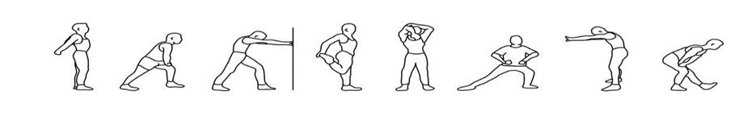
List muscle groups to stretch dynamically here:

Resistance training component length: ____________________

Exercise/machine | Resistance | Reps | Sets | Rest | Adaptations or alternatives to  suit client
Body weight exercise (including any functional/motor  skills exercises appropriate for the client) |  |  | Sets/reps/rest or duration of activity

Cardiovascular training (1 or more machine) – component length: ____________________

Equipment and approach | Programme  timings | Level/speed | RPE/HR | Adaptations or  alternatives to suit client

Cool down/flexibility – component length: ____________________

Cool down (if a re-warm or pulse lowering phase is required please detail in the space below)
CV machine (as  needed) | Time and intensity range
Post-workout stretches – indicate which stretches are maintenance (M) or developmental (D)
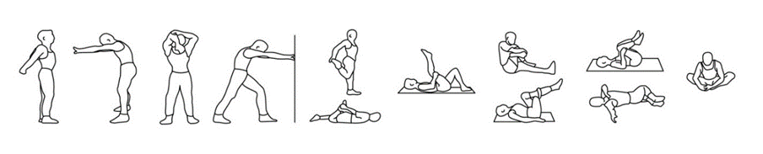
List additional stretches here:

Suggest other activities the client may be interested in within the fitness facility to complement their
programme.
Programme review dates.

Programming for client and from case studies assessment record and feedback (Assessor)
Gym-based programme planning and preparation (D/616/7950)
Learner’s name: |  |  |  | Date:
Assessor’s name: |  |  | IQA’s name:
The learner needs to achieve Pr1 through Pr6 to gain an overall pass in this section. Questioning is not permitted to confirm competence of practical skill. If the learner fails to meet the requirements of this section in full, they will need to be reassessed on this component of the session.
Programme
The learner demonstrated that they:
Pr1: Interpreted client information from consultation and screening for 2 clients (older adult, younger person) to select appropriate gym-based exercises to develop components of fitness, to include:
- cardiovascular fitness
- muscular fitness
- flexibility
- motor skills and functional ability
Pr2: Suggested some appropriate activities to complement the client’s programme according to their interests and goals.
Pr3: Planned realistic timings for each component within the programme.
Pr4: Planned safe and effective warm ups and cool downs including appropriate mobility/stretching.
Pr5: Identified methods of training suitable for the individual client for each component as appropriate
Pr6: Recorded programme plans in an appropriate format.
Assessor name: |  | Assessor signature:
Young Person Outcome | PASS/REFER | Date
Assessment Element 6 Case Study Programme Cards Assessor feedback: Young Person

